Tessa Maria Guazon

**Bose, Santiago (1949-2002)**

Santiago Bose grew up in Baguio City in Northern Philippines. In the 1950s and 60s, his early exposure to art was from close kin, helping his mother tend a souvenir shop and vacations spent with paternal cousins adept at drawing. At the age of 14, his talents were recognized by an American teacher at Brent School, from whom he learned the rudimentary skills of composition, drawing and rendering. The major phases of Bose’s career are from the late seventies to the early eighties; when Martial Law and the cultural programs of the Marcoses dictated to great degree art production in the capital. He stayed in the United States from 1980 to around 1986, going back to the Philippines at regular intervals. However, Baguio City remained the ground from which Bose’s awareness of identity and history would sprout. Designed as a hill station for Americans when they colonized the Philippines, Baguio is also home to indigenous peoples. The city best illustrates the struggles between cultures. It was thus that young Santiago Bose became acutely aware of the inherent contradictions that beset Philippine history and identity. Bose’s art is diverse in form, as he was bent on experimentation and invention. For him, art making was less about adherence to style or exploration of formal qualities, it was more about interrogation of identity, history, and culture.

Bose’s art is charged entity, much like the amulets or charms he fashioned at some point; which he imbued with combined wit, playfulness, and irreverence, all of which do not take from the ponderous weight of questions he raised about culture, the Filipino diaspora, colonial history, and religious beliefs. Identity, marginalization and struggle are persistent themes in his art, and his works are dynamic processes, encapsulating underlying tensions of society and emphasizing the artist’s indelible link to his cultural and communal roots. He reiterated once so often that the artist is to endeavor critical discourse through art, toward a deeper understanding of history and society.

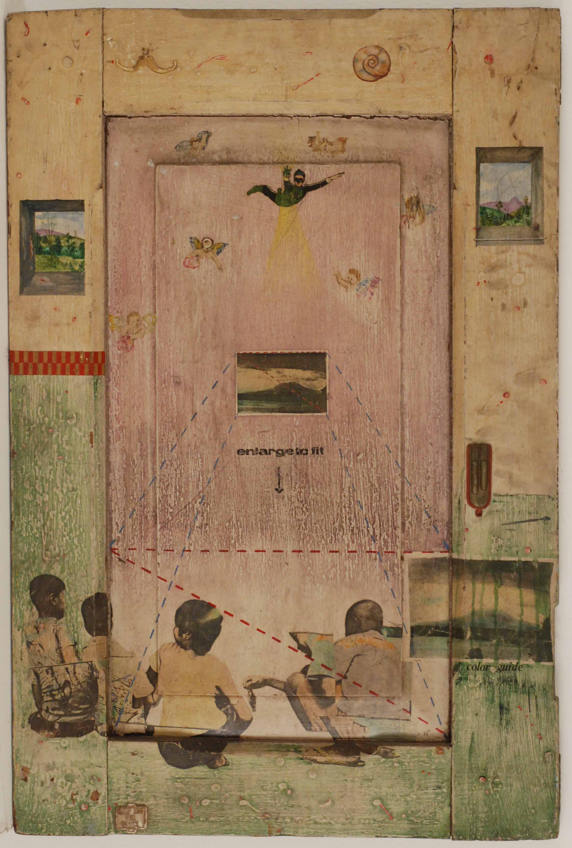

Santiago Bose, *An Afternoon at Sampaloc Lake*, 1976, mixed-media, Cultural Centre of the Philippines

.During his time in the United States, he was exposed to the marginalization rife in the New York art scene and associated with artists from a world diaspora. He also had solo exhibitions in Manila while shuttling back and forth between the Philippines and the United States. He returned to the Philippines in 1986, producing works up until 1993 when he participated in the First Asia-Pacific Triennial at the Queensland Gallery in Brisbane. His participation in the triennial ushered greater interaction between artists from Australia, the Philippines, and Southeast Asia. From around 1994 up to his untimely death in 2002, he began incorporating software technologies in works that were postmodern in character. Vital to these periods of art making was a persistent questioning of Philippine colonial and contemporary history as well as strivings to define indigenous identity and culture.

In 1986, Bose became a founding member of the Baguio Arts Guild, whose activities were responsible for bringing together artists in successful and well-attended art festivals. These gatherings brought attention to Baguio as an art center away from the Manila. His ideas about art and approaches to art making deeply influenced artists of younger generation with influence reaching far and wide.

Bose received Fine Arts training from the University of the Philippines Diliman and the West 17th Print Workshop in New York. His solo exhibitions were mounted in the Philippines, Australia and the US. His works are included in major collections such as the Babilonia-Wilner Foundation, Berkeley, USA; the Centro Wilfredo Lam, Havana, Cuba; the Museum of Contemporary Art, Sydney, the Queensland Art Gallery, Brisbane both in Australia, the National Museum of Singapore, and the Singapore Art Museum. In the Philippines, major works can be found in the collections of the Cultural Center and the Hiraya Gallery. Numerous corporate and private collections in the Philippines, Australia, the US and Singapore also house his art pieces.

**References and Further Reading**

---------------------. (2000) *Kayumanggi: Biographies of Philippine Visual Artists*. Quezon City: Peso Book Foundation, 17.

*--------------------*. (2004) *Espiritu Santi: The Strange Life and Even Stranger Legacy of Santiago Bose*. Makati City: Water Dragon.

Bay, Heidi Jaschim W. (undated) *A study of folk religious symbols in anting-anting as used by Santiago Bose in his late two-dimensional works*. Unpublished bachelors thesis, University of the Philippines College of Fine Arts.

Cultural Center of the Philippines. (2004) *In Memory of a Talisman: An exhibition of works by Santiago Bose*. Manila: Cultural Center of the Philippines.

Guillermo, Alice G. (1994) ‘Bose, Santiago Pavila,’ in *CCP Encyclopedia of Philippine Art*, Volume 4. Manila: Cultural Center of the Philippines, 322.

Virtual Sources and Information on Works

<http://www.pusod.org/b1808/santi/santi.html>

(Power and Poetics: Remembering Santiago Bose 1994-2002)

<http://www.anu.edu.au/hrc/research/WtoS/Hoffie2.pdf>

(Hoffie Pat. 2003. Santiago Bose: Magic, Humour and Cultural Resistance)

<http://www.artlink.com.au/articles/2457/santiago-bose-1949-2002/>

(Alison Carroll Obituary, 2003)

<http://www.lilledeshan.com/finding-santi/>

(Lilledeshan Bose Personal website)

<http://www.c-artsmag.com/articles/detail.php?Title=Santiago+Bose++Gone+Haunting&articleID=116>

(Eileen Ramirez, Santiago Bose Gone Haunting)

<http://artasiamerica.org/artist/detail/86>

(Artist profile, Asian American Arts Centre with a comprehensive set of related resource)

<http://yuchengcomuseum.org/art-exhibits/remix-santiago-bose/>

(Exhibition Press for Remix)